Dataset broken into 10 parts of 8000 Interactions (Original 80/20 split on 100k): How to define test?

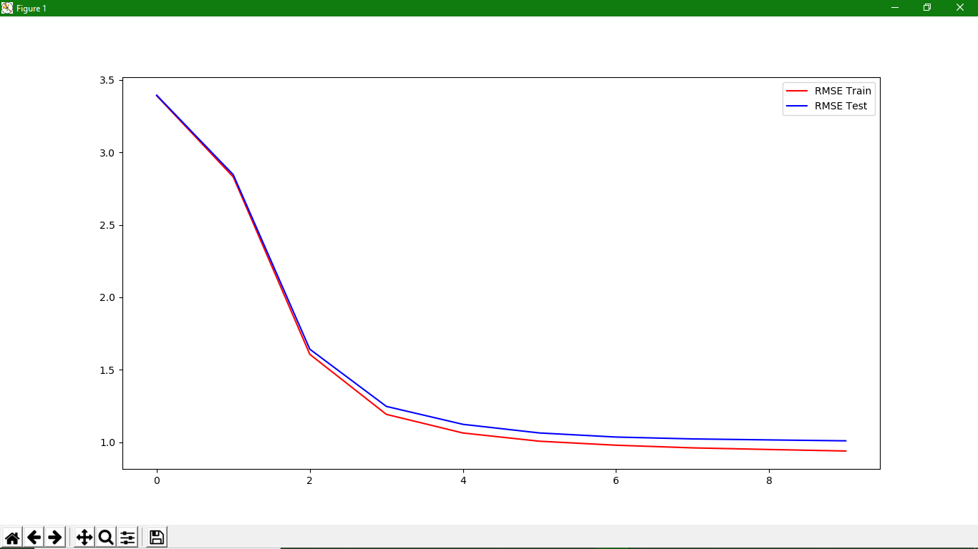

**Parameters** : 50 Steps x 1 iteration. 90/10 split

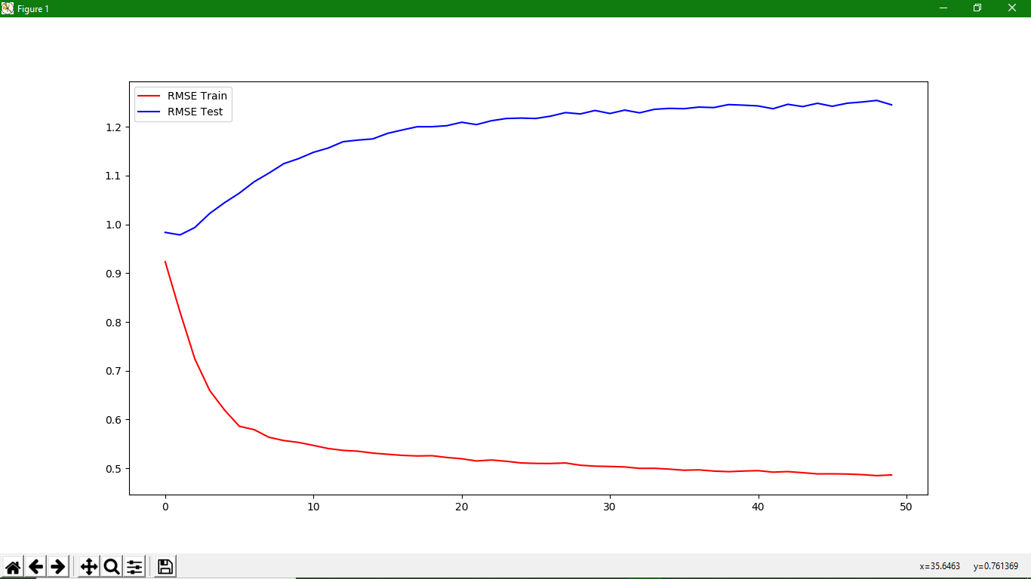

**Parameters** : 50 Steps x 1 iteration. 80/20 split

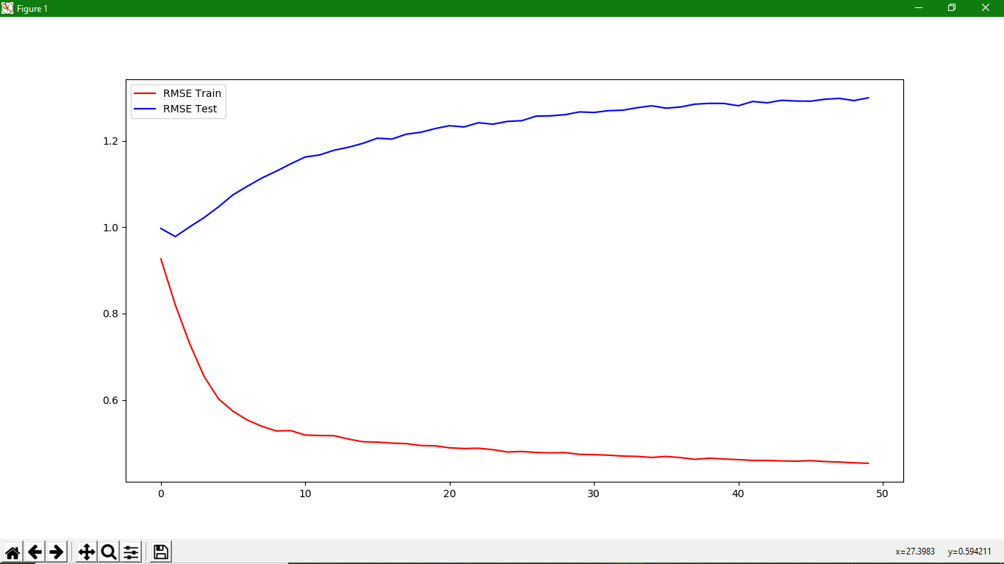

|  |  |  |
| --- | --- | --- |
| **Iteration** | **Train RMSE** | **Test RMSE** |
| 1 | 0.92048186 | 0.99910051 |
| 2 | 0.81162608 | 0.98670751 |
| 3 | 0.71692789 | 1.00611413 |
| 4 | 0.65404791 | 1.0309608 |
| … | … | … |
| 48 | 0.46033046 | 1.27686942 |
| 49 | 0.45619506 | 1.27536404 |
| 50 | 0.45576793 | 1.27951813 |

**Parameters** : 50 Steps x 1 iteration. 70/30 split

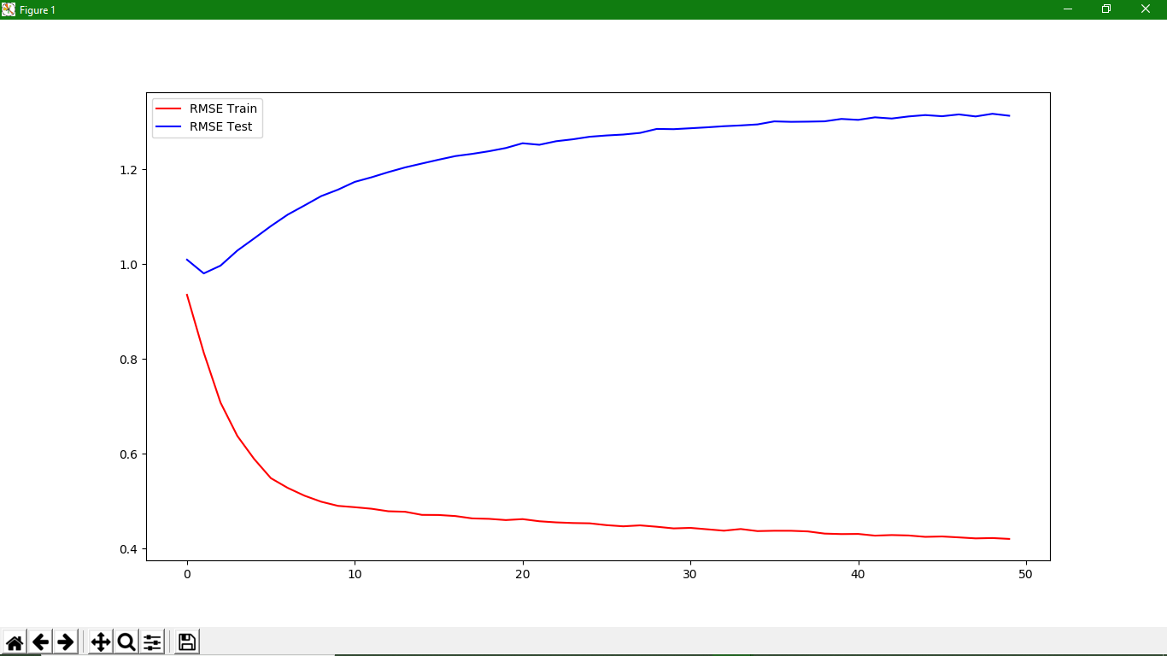

**Parameters** : 50 Steps x 1 iteration. 60/40 split

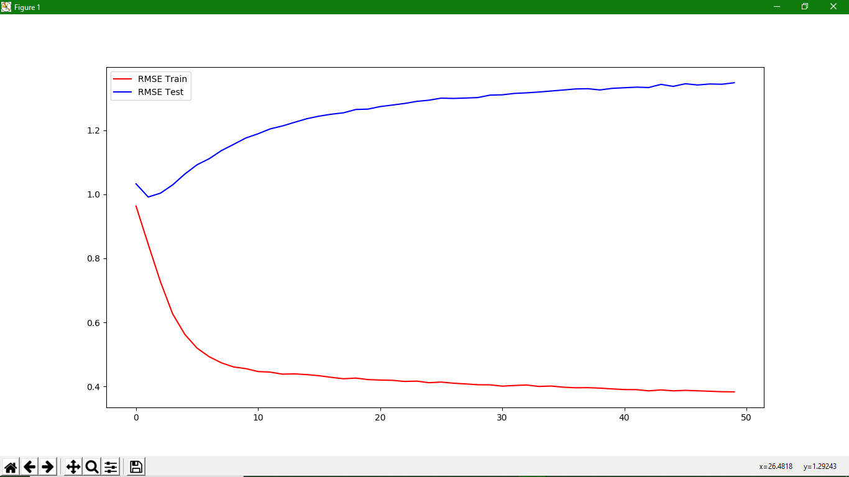

**Parameters** : 50 Steps x 1 iteration. 50/50 split

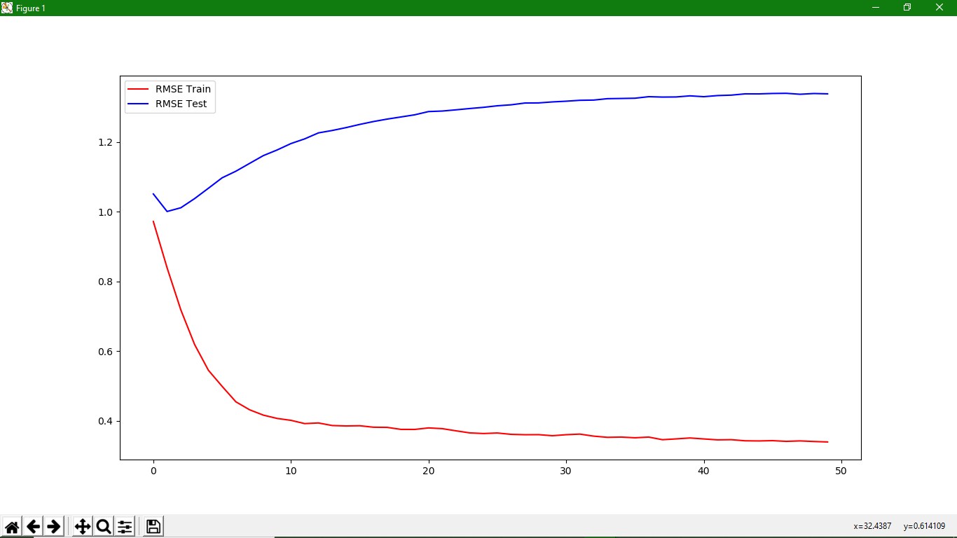

**Parameters** : 50 Steps x 1 iteration. 40/60 split

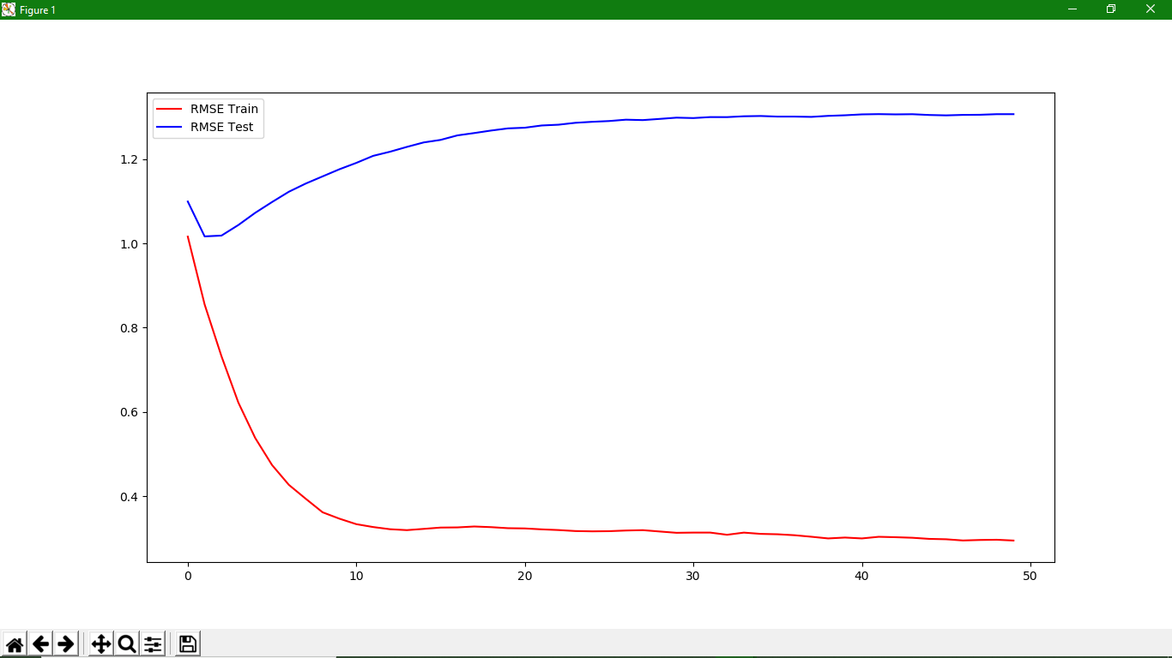

**Parameters** : 50 Steps x 1 iteration. 30/70 split

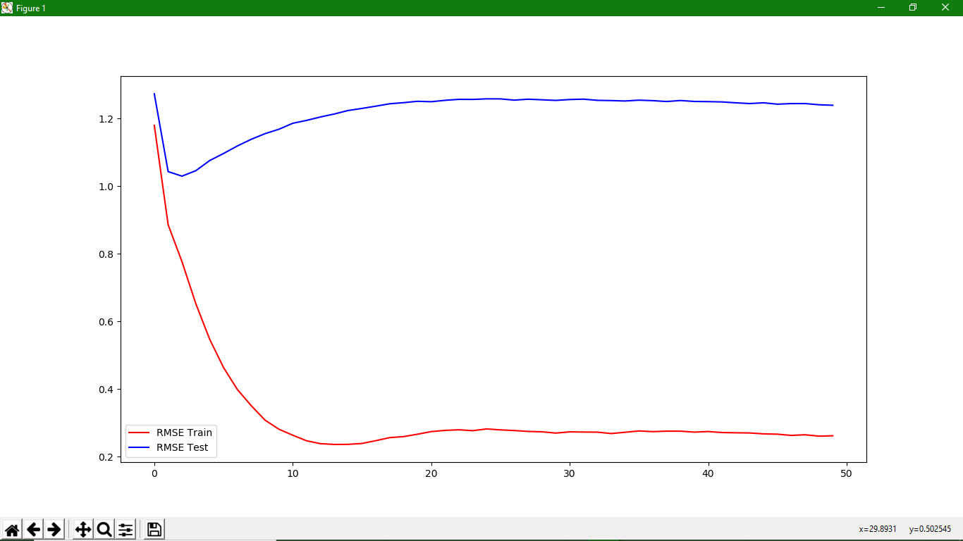

**Parameters** : 50 Steps x 1 iteration. 20/80 split

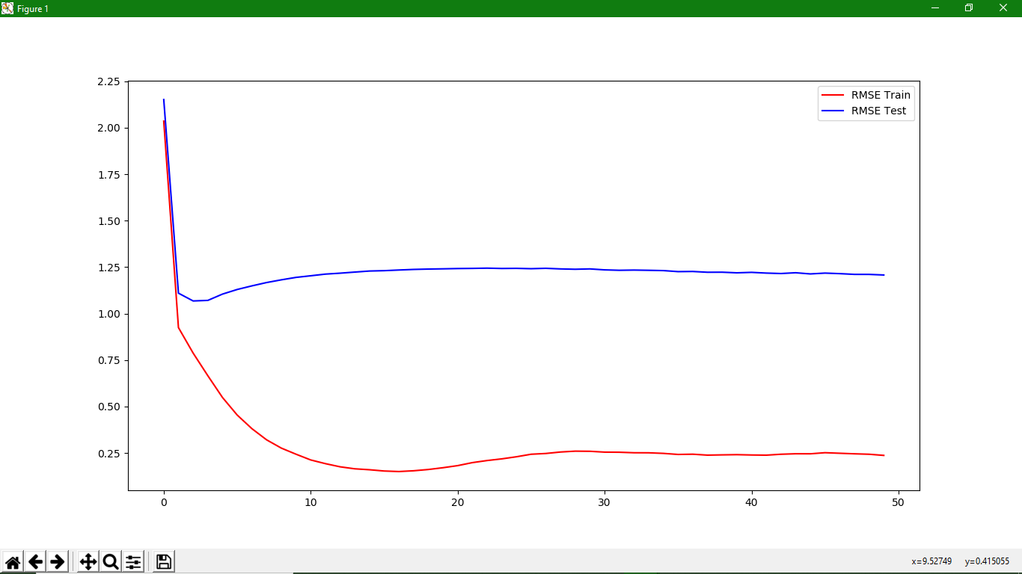

**Parameters** : 50 Steps x 1 iteration. 10/90 split

